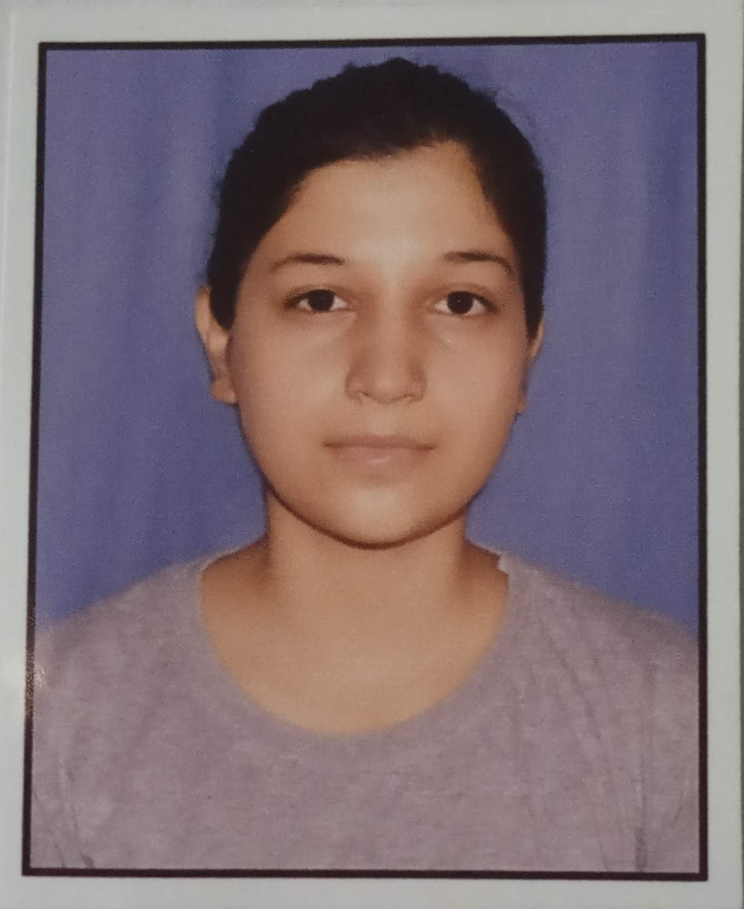
ANAMIKA KUKRETI
D/O Mr. Vinod Kukreti
Temporary Address- Villa-60, Palm city Dehradun
Pauri Garhwal,Uttarakhand (India).
Mob No: 7895362720
kukretianu0305@gmail.com

CAREER OBJECTIVE
To work in a healthy, competitive environment that can provide me umpteenth opportunities & continual up gradation of my aptitude & interpersonal skills, extracting best tout of me, thus helping me to grow at professional as well as personal level thereby directing my future endeavors as an asset to an organization.

ACADEMIA

- XII - U.K. Board in the year 2017.
- X - U.K. Board in the year 2015.
- B.Sc(CBZ)- SDSUV University in the year 2021.
- Six months Basic Computer course from CAIMS Institute Kotdwara.

HOBBIES
- Reading books
- Listening Music
KEY SKILLS/STRENGTHS
- Adaptable to the new environment
- Dedicated towards work given
- Willingness to learn

PERSONAL DETAILS
Father’s name : Mr. Vinod Kukreti
Date of birth : 18 August 2000
Religion : Hindu
Nationality : Indian
Languages known : English, Hindi

DECLARATION
I declare that the above details are correct and true to the best of my knowledge.
DATE :- (Anamika Kukreti)
PLACE:-

