CURRICULUM VITAE

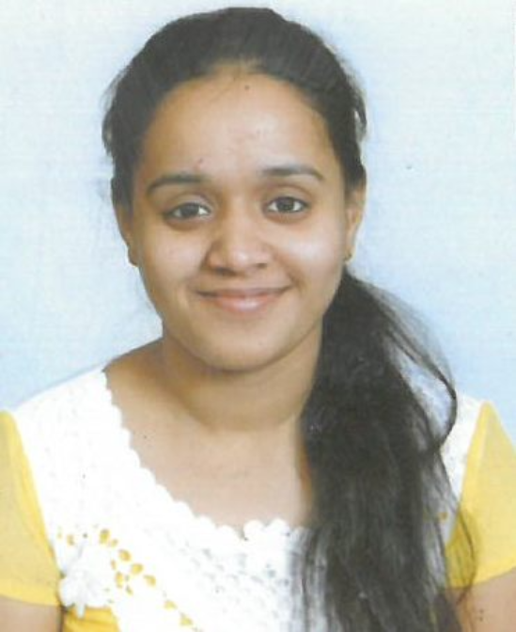

Contact no. 8447268388
E-mail – nehashukla781995@gmail.com

Address- A-1/309 Sector-17 Rohini Delhi
Pin code-110089

STRENGTH AND SKILL CAREER OBJECTIVE

Quick Learner Self motivated Adjusting nature Co-operative Self-disciplined Hardworking Self Confident
Thrive on challenges Open Minded
Clear vision
Commited professional
To pursue a challenging and growth oriented career in an esteemed organization while enjoying a positive work and environment, which would provide me with an opportunity to enhance my knowledge and skills for individual as well as organization development.

PROFESSIONAL KNOWLEDGE&SKILLS
Advance knowledge of Microsoft office(Ms-word,Ms-excel,Ms- power point)
Basic knowledge of
- (IT) information technology
- C language
- Data Entry

PERSONAL
KNOWLEDGE

Father's name- Mr.Ramesh Kumar
DOB-07th August 1995 Gender-Female
Nationality-Indian Current status-Married Language-English,Hindi
Hobbies-Book reading, Teaching and listening music

EDUCATION

- 10th passed from CBSE Board in 2010.
- 12th passed from CBSE Board in 2012.
- Diploma in Early childhood care and education.
- Graduated in B.A English(hons.) from Delhi University in 2015.
- Post graduate in M.A English(hons) from IGNOU.

