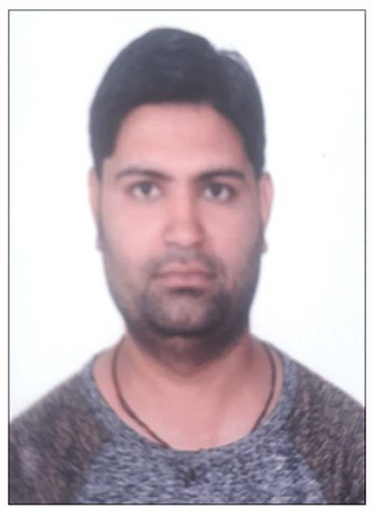CURRICULUM VITAE

VIVEK KUMAR CHAUBEY

Mob No: +91-8178647240
Email: vivekchaubey1122@gmail.com Address: Village- Gorbi,
Post- Gorbi, City- Singrauli, District- Singrauli [M.P] Pin code: 486892
Career Objective

To make a successful career in an organization where I can prove myself as a key resource and find opportunities for learning and growth.
Academic Qualification
Qualification Year |  | College/School | Board/ University | Aggregate Or  Percentage
B.E. 2014 |  | Rajiv Gandhi Proudyogiki | Rajiv Gandhi | 6.8 [CGPA]
[Mechanical Engg.] |  | Mahavidhyal,Bhopal [m.p] | Proudyogiki | 68 %
 |  |  | Vishwavidya
 |  |  | laya
 |  |  | Bhopal[M.P]
12th | 2010 | Saraswati Shishu Mandir higher school,Gorbi,Singrauli [M.P] | s M.P. Board | 68.4%
10th | 2008 | Saraswati Shishu Mandir Higher Secondary School, | M.P. Board | 77.8 %
 |  | Gorbi,Singrauli [M.P]
Industrial Training

o COMPANY: NTPC vindnagar ,Singrauli [M.P].

Academic Project

o PROJECT: “Automatic Tyre Inflation System”.

Technical Proficiency

o SHOFTWARE KNOWN :

HVAC Heating Ventilation & Air conditioning system. Welding Machine , lathe machine operater.
AutoCAD & Catia.
Mechanical software design analysis PLC & SCADA. Ms office. - world , excel, PowerPoint.
Email - filters, folders , mail merge , rules.

Work Experience

[I[ COMPANY : OM INDUSTRIES
Rudrapur, Udhamsingh Nagar, Uttarakhand

EMPLOYEE :

DESIGNATION :

TENURE :

JOB PROFILE :
Vivek kumar Chaubey Graduate Engineer Trainee From 06/01/2015 to Dec. 2020
Automobile Industries

[ II ] COMPANY : Indian Institute Of Skill Development Pvt. Ltd.

DESIGNATION : Domain Trainer

TENURE : From 05/02/2021 To Till Date

JOB PROFILE : HEMM Trainer Of Skill Sector

- Performed Troubleshooting. Diagnostic and Repair of HEMM Equipment Like Dumper, Drill, Road Roller, Wheel Loader, Paver, Excavator, Compactor, Truck Crane, Dozer and Grader.
- Performed Troubleshooting, Diagnostic and Repair of Light and Heavy Vehicles Like Truck, Bus and Jeeps.
- Preparation of Monthly DO Reports, Spares Report, Checklist, Consumptions, HRM Report.
- Maintaining the Safety Items.

Interest of Subject

- Basic Mechanical Engineering
- Workshop maintenance
- IC Engine
Personality Traits

- Highly motivated and eager to learn new things.
- Strong motivational skills.
- Ability to produce best result in pressure situation.
- Ability to work individual as well as in group.
- Also courageous & dedicated.

Interpersonal Skills

- Ability to perform the task in hand responsibly.
- Ability to cope up in different situations.
- Ability to build relationships and set up trust & create healthy environment.

Hobbies&Interests

- Workout
- Playing Cricket
- Listening Music
- Plantation
Personal Details

- Father’s Name : Mr. Laleshwar Prasad Chaubey

- Mother’s Name
- Date of Birth
- Language Known
- Contact No.
- Permanent Address

- Pin Code
- Marital Status
: Smt. Meena Devi
: 10th January, 1993
: English, Hindi
: +91- 8178647240
: Village- Gorbi , Post- Gorbi, City-Singrauli, District-Singrauli [M.P.]

: 486892
: Single

- Nationality : Indian

Declaration

I hereby declare that the above information is true to the best of my knowledge.

PLACE: SIGNATURE

DATE: VIVEK KUMAR CHAUBEY

