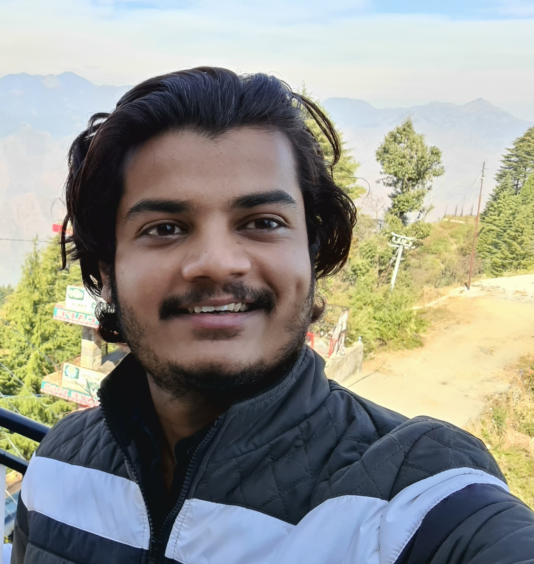 |  |  |  | VIBHOR  BURMAN

OBJECTIVE
To contribute towards the betterment of society and serve its people through my skills.

Education
High School and Intermediate from BROOKLYN SCHOOL, DEHRADUN (CISCE BOARD) with a decent percentage.
Graduation in Science Stream from D.B.S(P.G.) College, Dehradun (H.N.B. GARHWAL UNIVERSITY) and Pursuing Masters in Physics from the same College.

Other Skills
- Basic Knowledge of Online teaching.
- 5 years of experience of tutoring Middle School and Secondary School Students.

Personal Information
Father’s Name- Mr. MANGHE RAM
Date of Birth- 02/08/1996
Gender- MALE
Nationality- Indian
Marital Status- Unmarried
Languages Known- Hindi and English
Strength- Good Communication skills and a quick learner.
Hobbies-Reading Books, Exploring Nature, Cycling, playing guitar, singing and listening to music and Podcasts.

 |  | H.No.-121, Cross 8-A Tapovan Enclave, Tarla Aamwala, Raipur, Dehradun, Uttarakhand.
 |  | 8126229996
 |  | vibhor3vibs@gmail.com

