RESUME

NISHA
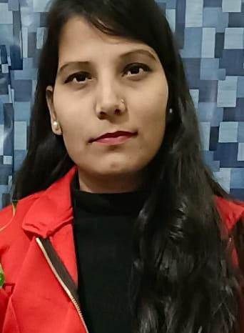
F-34 Ber Sarai
Near j.N.U old campus ,new Delhi
Mobile no: 8920122779
Academic qualification
10th pass from C.B.S.E board (2011)
12th pass from C.B.S.E board (2013)
Bachelor of arts in Indira Gandhi national open university (2022)
Diploma course in elementary teacher education (2015)
Other qualification
Basic knowledge in computer
Central teacher eligibility test (CTET) (100/150)
Personal skill
Honesty
Writing
Punctuality
Regularity
Passion for work
Experience
3 years experience in ganga devi public school badarpur new Delhi
1 years experience in bal vaishali public school badarpur new Delhi
1 years experience Brilliant public school munirka

Personal profile
Father’s name Mr. Narendar kumar Mishra
Date of birth 7/5/1996
Sex Female
Marital status single
Language known Hindi/English
Nationality Hindu

