RESUME
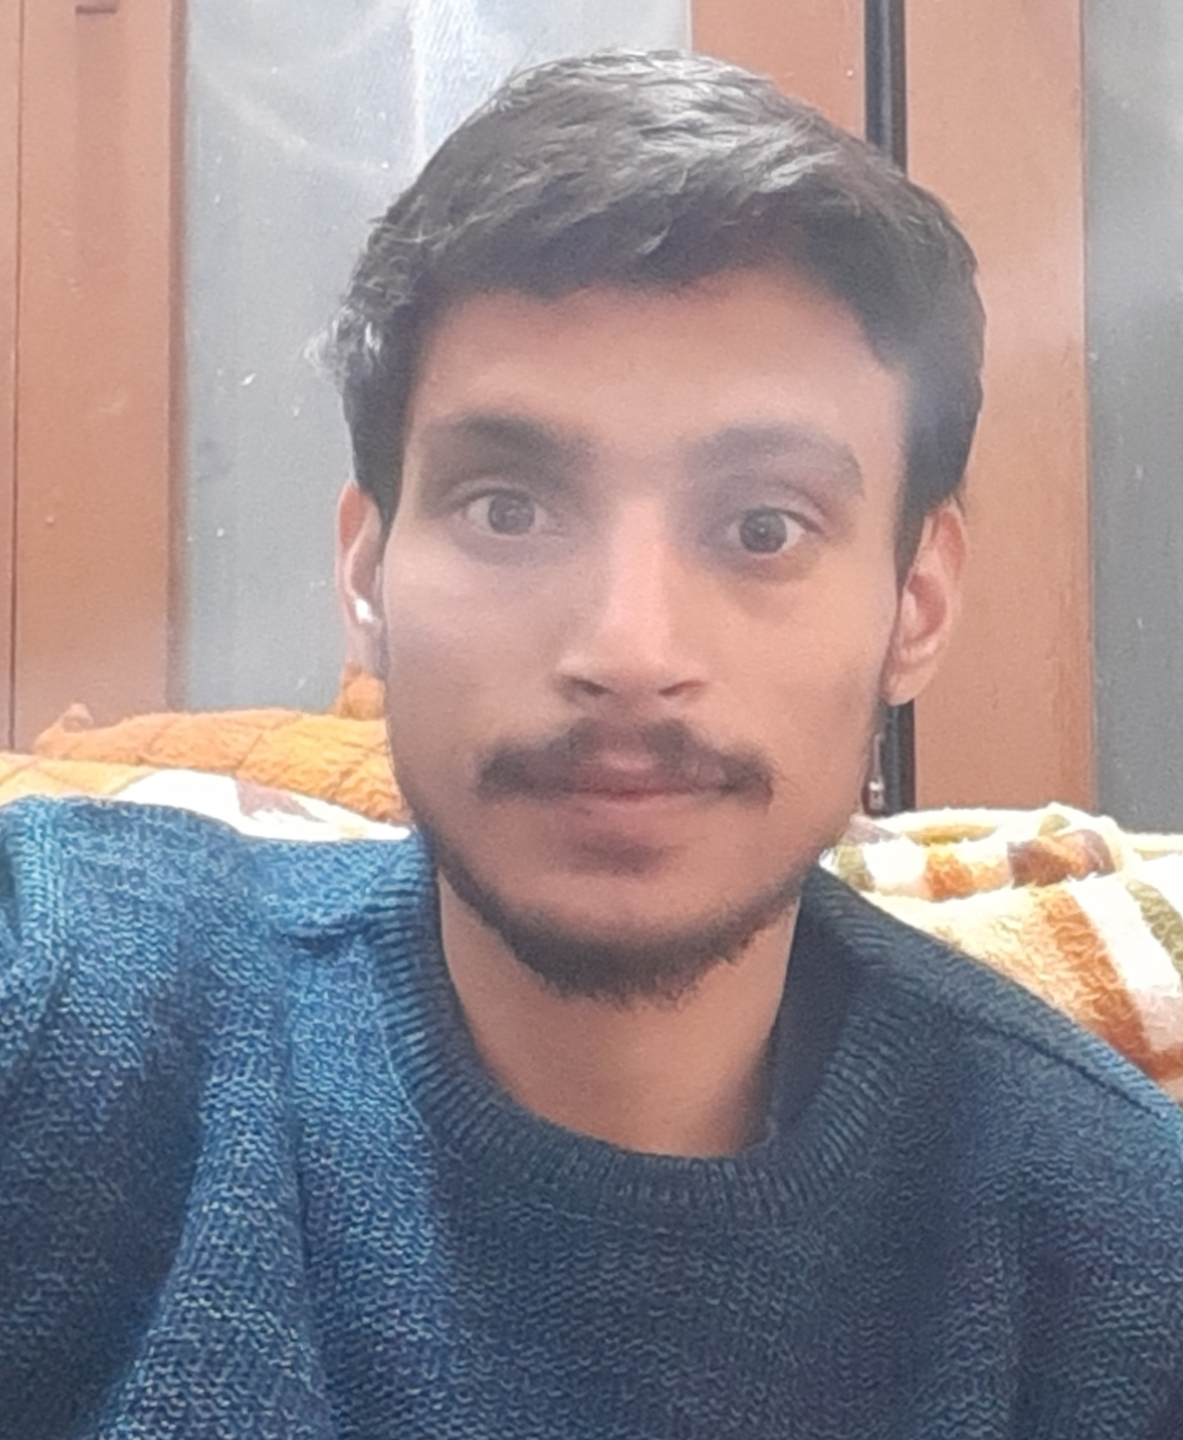

Name : Ankit Bijlwan
Address : C/o S.S. Negi
E Block, LNo. 6B, Hno. 207, Saraswati Vihar,
Ajabpur khurd, Dehradun,248121.
D.O.B. : 18-03-1997
Gender : Male
Email : ankitbijlwan24@gmail.com
Phone No. : 7906800635

CAREER OBJECTIVE:
- To enhance my educational and professional skills in a stable and dynamic workplace.

EDUCATIONAL QUALIFICATION:

Year | Degree/Qualification | University/Board | CGPA/%
2020 | M.Sc. Physics | S.D.S.U.V | 71.55%
2018 | B.Sc. (Hons.) Physics | GEHU | 8.74
2014 | Intermediate | CBSE BOARD | 86.00%
2012 | High School | UTTARAKHAND BOARD | 89.20%

EXPERIENCE:
Tutoring experience (11th & 12th – CBSE Math, Physics & B.Sc. Physics) – 5 years

LANGUAGES:
English, Hindi

STRENGTH:
- Flexibility and Adaptability, Listening, Creative, Quick learner, Dedicated, Hardworking, Self-motivated, Goal oriented: results achiever, Meeting deadlines Convenient and compatible to work and be friends with co-workers easily.

HOBBIES / INTEREST
Badminton, Music (bansuri playing basic level) etc.

Declaration

I hereby declare that all information mentioned above is absolutely true to my knowledge.

Yours Sincerely

